Domo Arigato, Mr. Roboto

Using Legos WeDo
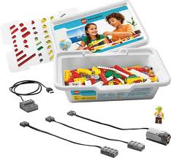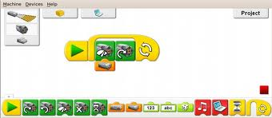

To Learn the Engineering Process

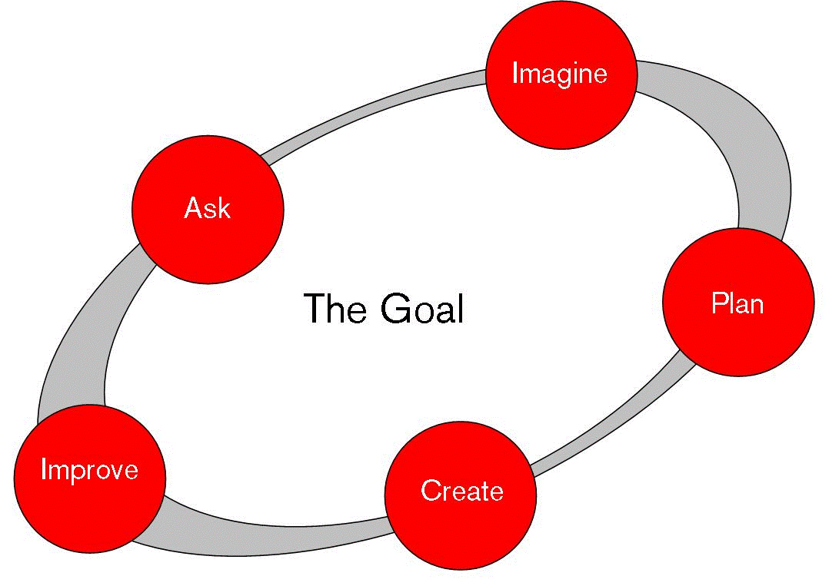

NAME: __________________________________________________________________________

Lego Robotics Expectations:
Over the next 2 weeks, you will work independently to first learn:
- To inventory and be completely responsible for our own set of Legos
- The working components of the Lego WeDo pack
- The programing adapted for each component of the Lego WeDo pack
- How to integrate programing with components to achieve a goal
- How to read and follow schematic instructions
- How to read and follow programing instructions
- How to apply the knowledge of building and programing to create your own robot to accomplish a given task
Monday | Tuesday | Wednesday | Thursday | Friday
Learn:  - Rules & Responsibility  Build:  - Component Builds  Program:  - Component Programs | Learn:  - Review  - Inventory  - Components  - Programing  Build:  - Book Build  - Modify  Program:  - Book Program  - Modify | Learn:  - Review  - Book Build  - Computer lessons  Build:  - Indy Book Build  - Modify  Program:  - Indy Book Program  - Modify | Learn:  - Review  - Book Instructions  - Book Programs  Build:  - Student ASK  - Student IMAGINE  Program:  - Student ASK  - Student IMAGINE | Learn:  - Design Process  Build:  - Student PLAN  Program:  - Student PLAN
Learn:  - Build Planning  - Program Planning  Build:  - Student CREATE  Program:  - Student CREATE | Learn:  - Component Functions  - Component Programs  Build:  - Student IMPROVE  Program:  - Student IMPROVE | Learn:  - Review Design Process  Build:  - Student  - ASK  - IMAGINE  - PLAN  Program:  - Student  - ASK  - IMAGINE  - PLAN | Learn:  - Review building plan  - Review Program Planning  Build:  Student CREATE  Program:  Student CREATE | Learn:  - Adaptation & Presentation  Build:  - Modify  - Adapt  Program:  - Modify  - - Adapt
What is it that we are planning to do in the next two weeks? Why is my teacher letting me play with Legos?
__________________________________________________________________________________________
__________________________________________________________________________________________
__________________________________________________________________________________________
DAY 1
What is it that I am being asked to do during the next two weeks?
__________________________________________________________________________________________________
__________________________________________________________________________________________________
Before we can IMAGINE what our robot will look like and what it will do, we need to know our materials. The materials provided in the LEGO WeDo kit each have unique capabilities and certain limitations. Through the Mini-Build process, we must learn about the components (specialized legos) and what they will help us to accomplish. There are two different types of components that we need to learn more about. There are those that can be used and altered with programing and those that are used and altered physically.
Identify the PROGRAMABLE components in the WeDo Kit. (Hint: they probably have a cord or some electronics)
Name:
Sketch:

Use:

Identify the PHYSICAL components in the WeDo Kit. (Hint: they probably do not have a cord or electronics AND look different from typical Legos)
Name:
Sketch:

Use:

BUILD
Select a specific PHYSICAL and PROGRAMABLE component and begin Mini-Lesson Build. When you are finished building, draw a sketch of what the build looks like from the TOP and SIDE. Then predict what you might be able to make it do.
TOP | SIDE
What will it do?

PROGRAM
Now you need to PROGRAM your Mini-lesson Build. Continue with the Lego software and follow their directions on how to program your Mini-lesson Build. Enter the LEGO PROGRAM as shown by the icons in the screen below.
MODIFY
Review what your Mini-lesson build looked like, what components were involved and what the program made it do. Now it is your turn to add some creativity. Make 1 modification or change to the build and predict what it will allow you to do differently than it did before. Record your design and prediction below.
TOP | SIDE
What will it do?

Now you need to program your modified Mini-lesson Build. Enter in your modified or changed program below. Then predict what it will make your modified Mini-lesson Build do.
What will it make your Modified Mini-lesson Build do?

DAY 2
Today you will begin by completing your inventory.
List any pieces you are missing below
Name:

Sketch

Identify a plan to help you manage your supplies better if you are missing ANY pieces.
__________________________________________________________________________________________
__________________________________________________________________________________________
__________________________________________________________________________________________
BUILD:
Now it is time to complete a full lesson build. You will be responsible for constructing the #1 build in the Lego WeDo instruction booklet. When finished please document your build and make a prediction below.
TOP | SIDE
What will it do?

PROGRAM
Once your build is complete, it is time to program your robot. Follow the program given by the Lego Software. Document that program below. Then identify what your robot does.
What does your robot & program do?

Name the PROGRAM and PHYSICAL components contained in this robot.
PHYSICAL | PROGRAMABLE
-  -  -  - | -  -  -  -
What to the PHYSCIAL and PROGRAMABLE components allow your robot to do?
__________________________________________________________________________________________
__________________________________________________________________________________________
__________________________________________________________________________________________
MODIFY
Identify 1 thing you would like your robot to do differently.
_________________________________________________________________________________________
Describe and diagram what you will need to change to the build of your robot to make these different actions possible.
Describe in words | Diagram in pictures

Demonstrate a program that will allow your robot to complete the 1 new task that you want it to do.
What does your robot & program do?

Did your modifications work? (YES) (NO) (KIND OF)
Why did it work or not work? What was the result of the change? How might your new knowledge be useful in designing and building future robots?
__________________________________________________________________________________________
__________________________________________________________________________________________
__________________________________________________________________________________________
__________________________________________________________________________________________
DAY 3:
Today you will begin by completing your inventory.
List any pieces you are missing below
Name:

Sketch

Identify a plan to help you manage your supplies better if you are missing ANY pieces.
__________________________________________________________________________________________
__________________________________________________________________________________________
__________________________________________________________________________________________
BUILD:
Now it is time to complete a full lesson build of your own choice. Look through the instruction booklet and identify a build that is of interest to you. When you have selected a build, document it below by recording its name.
NAME: ____________________________________________________________________________________
Now you must build your robot. When finished please document your build and make a prediction below.
TOP | SIDE
What will it do?

PROGRAM
Once your build is complete, it is time to program your robot. Follow the program given by the Lego Software. Document that program below. Then identify what your robot does.
What does your robot & program do?

Name the PROGRAM and PHYSICAL components contained in this robot.
PHYSICAL | PROGRAMABLE
-  -  - | -  -  -
What to the PHYSCIAL and PROGRAMABLE components allow your robot to do?
__________________________________________________________________________________________
__________________________________________________________________________________________
MODIFY
Identify 1 thing you would like your robot to do differently.
_________________________________________________________________________________________
Describe and diagram what you will need to change to the build of your robot to make these different actions possible.
Describe in words | Diagram in pictures
Demonstrate a program that will allow your robot to complete the 1 new task that you want it to do.
What does your robot & program do?

Did your modifications work? (YES) (NO) (KIND OF)
What happened because of your modification? How might this help you with future robot builds?
__________________________________________________________________________________________
__________________________________________________________________________________________
__________________________________________________________________________________________
DAY 4:
Now the time has come to create a robot design of your very own. You have viewed the videos of Lego Robots that other people have built. The creators of those robots had to think of a single task they wanted their robot to complete. Before you begin to IMAGINE, PLAN or CREATE, you must first ask yourself:
ASK:
What 1 task do I want my robot to accomplish?
__________________________________________________________________________________________
__________________________________________________________________________________________
IMAGINE:
Now you must do the hardest part of any designer. You must make what you have fit what you want. Remember that we can only work within the materials of our WeDo kit. This doesn’t mean you should change your goal, but you will need to be creative and opening minded in order to make it work. Our first step should be to identify which components (PHYSICAL & PROGRAMABLE) and which Lego parts will be needed. Please list and sketch them below. As you list and sketch, be sure to explain in words or your diagram what the parts will do and why you need them.
Sketch: | Part Name: | Reason:
As we have discovered, the build of your robot is only ½ of the task. We must also program our robots. Try to identify some of the program icons that you will need to make your robot do the 1 task you want.
Icon | Name | Reason

Before you can move on to the planning portion of your build, take some time and research each of the PHYSICAL and PROGRAMABLE components as well as the programing icon that you listed above. Be sure that you know how they work and what they can and cannot do.
Take some notes the robots and the programs that Lego Software demonstrates. Be sure to include any important to details about components or programs that you might want to use in your robot.
Program or Component | Important notes to remember
DAY 5-10:
PLAN:
It is time to begin the planning process of your engineering cycle. Think back to the first build from the Lego instruction booklet. Did the detailed pictures help you build the robot correctly? Could you imagine trying to build any of the Lego builds from one single picture or just written words? It would be just too hard. Your job will be to combine the PLAN and CREATE process in order to both build your robot and create a step-by-step plan that any student in the class could follow to build your robot from scratch. Be sure to record what you robot looks like as well as what color the pieces are and how to put them together as you build. You will NOT be able to program your robot until that step is complete.
1 | 2 | 3
4 | 5 | 6
7 | 8 | 9
10 | 11 | 12

CREATE:
Build Name:
Diagram:

Digital Picture:

Program:
My robot will . . .

IMPROVE: NAME:__________________________________________________
Before you can improve your robot, you first have to test it. Bring you robot to a computer and create the program you planned above. Circle the box that matches what attempt number you have just completed:
1st | 2nd | 3rd | 4th | 5th | 6th | 7th | 8th | 9th | 10th
MY ROBOT
Did your robot work at all?
__________________________________________________________________________________________________
Did it work like you expected? Why or Why not?
__________________________________________________________________________________________________
__________________________________________________________________________________________________
__________________________________________________________________________________________________
__________________________________________________________________________________________________
What changes will you have to make to the program? What changes will you have to make to the robot?
Program: _________________________________________________________________________________________
_________________________________________________________________________________________________
__________________________________________________________________________________________________
Components: _____________________________________________________________________________________
_________________________________________________________________________________________________
__________________________________________________________________________________________________
ME
What part of the engineering process do you need to improve on in order to create a more effective robot? Do you need to work on your understanding, organization, planning or knowledge or attention to detail or some other areas in order to become a more effective engineer?
_________________________________________________________________________________________________
__________________________________________________________________________________________________
__________________________________________________________________________________________________
What will you have to do this time to be better prepared for a successful robot build?
_________________________________________________________________________________________________
__________________________________________________________________________________________________
__________________________________________________________________________________________________
Now that you have a plan to fix one problem, you have to re-enter the IMAGINE, PLAN & CREATE process. Complete the diagrams below as well as the programing section BEFORE you attempt to re-test your robot. You must have this form approved each time you want to test and modify your robot.
Build Attempt Number _________________ | Build Attempt Number ___________________
Diagram of what my build looks before modifications | What my robot will look like after modifications
Explain all changes and why you are making them. Remember you need to focus on 1 improvement at a time.
-

-

-

-
My old program before modifications
When I used this program my robot . . .

This was not OK because . . .

My new program after modifications
I made the changes in this program so that my robot will . . .

Teacher’s Initials to Build & Test

