Explorers in the Age of Discovery
Name: ____________________________________ Ship’s Name:___________________________________

The Challenge:
- You and a partner will design, construct and sail a ship as far as you can along a specialized track using only wind power
- You must be able to explain the choices you made in materials, design and construction of your vessel
- You will use materials provided by your teacher, friends or from your own home to construct the most efficient sailing ship
- You must use mathematics, research and the scientific/engineering process to improve your ship’s performance
- You will sail your ship against the entire 5th grade and compete for the title of Expert Explorer Extraordinaire
What am I being asked to do?
__________________________________________________________________________________________________
__________________________________________________________________________________________________
__________________________________________________________________________________________________
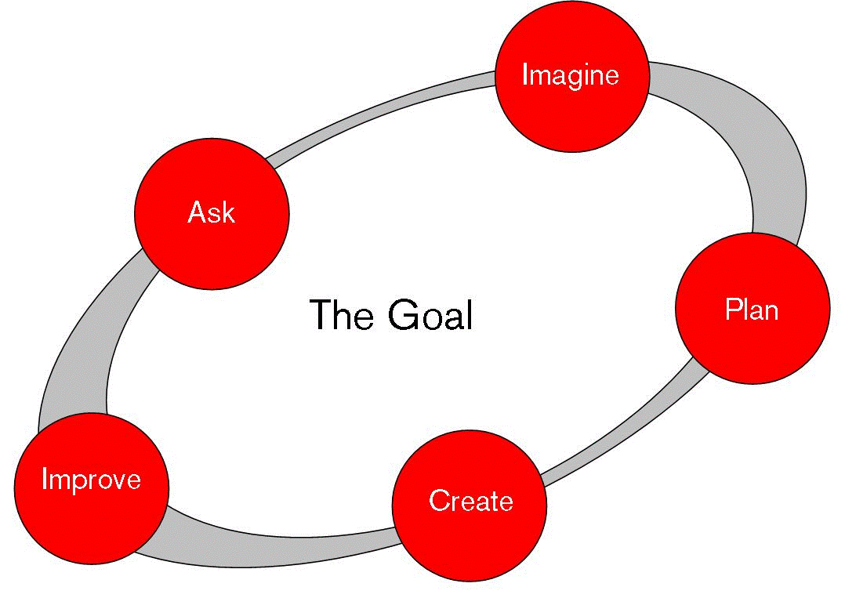
___________________________________________________________
___________________________________________________________
___________________________________________________________
___________________________________________________________

Mechanical Engineer
Observe the properties of as many different materials as possible. Use the table below to identify 3-5 criteria you would want in a good “sail material”. Rate each of the materials you observe on a scale of 1-5 based on how they meet your criteria.
Criteria  Materials  ↓ |  |  |  |  |  | Total
 | 1 – 2 – 3 – 4 – 5 | 1 – 2 – 3 – 4 – 5 | 1 – 2 – 3 – 4 – 5 | 1 – 2 – 3 – 4 – 5 | 1 – 2 – 3 – 4 – 5
 | 1 – 2 – 3 – 4 – 5 | 1 – 2 – 3 – 4 – 5 | 1 – 2 – 3 – 4 – 5 | 1 – 2 – 3 – 4 – 5 | 1 – 2 – 3 – 4 – 5
 | 1 – 2 – 3 – 4 – 5 | 1 – 2 – 3 – 4 – 5 | 1 – 2 – 3 – 4 – 5 | 1 – 2 – 3 – 4 – 5 | 1 – 2 – 3 – 4 – 5
 | 1 – 2 – 3 – 4 – 5 | 1 – 2 – 3 – 4 – 5 | 1 – 2 – 3 – 4 – 5 | 1 – 2 – 3 – 4 – 5 | 1 – 2 – 3 – 4 – 5
 | 1 – 2 – 3 – 4 – 5 | 1 – 2 – 3 – 4 – 5 | 1 – 2 – 3 – 4 – 5 | 1 – 2 – 3 – 4 – 5 | 1 – 2 – 3 – 4 – 5

- Which material do you predict will work best for a sail design? Explain your prediction.
_______________________________________________________________________________________________
_______________________________________________________________________________________________
_______________________________________________________________________________________________
- Which materials do you predict will NOT work well for a sail design? Explain your prediction.
_______________________________________________________________________________________________
_______________________________________________________________________________________________
_______________________________________________________________________________________________
- Select the material from which you will attempt to construct your sail.
_______________________________________________________________________________________________
- In what criteria did your selected material score very high? In what cretiera did your selected material score very low? Describe the advantages and disadvantages of using the material you selected.
__________________________________________________________________________________________________
__________________________________________________________________________________________________
__________________________________________________________________________________________________
__________________________________________________________________________________________________
__________________________________________________________________________________________________
Think about things you have experienced in your life that “catch the wind”. Into what shape were those items formed? Name those items and draw their shapes in the spaces below.
- What shapes do you predict will work best as a sail?
__________________________________________________________________________________________________
__________________________________________________________________________________________________
__________________________________________________________________________________________________
- Which shapes will work best with the materials you predict would make the best sail? Explain your prediction.
_______________________________________________________________________________________________
_______________________________________________________________________________________________
_______________________________________________________________________________________________
Select the shape you will use to design your sail:
_______________________________________________________________________________________________
Make two ABCD diagrams of possible designs for your sail.

Construction:
Materials I will use to construct my sail. . . | I will use this material because. . .
1)  2)  3)  4)  5)  6) | 1)  2)  3)  4)  5)  6)

Plan your “boat build”
Step 3
Step 2
Step 1

Step 6
Step 5
Step 4

Step 9
Step 8
Step 7

Testing:
Shape & Size | What Happened?
- Draw an ABCD diagram of your ship  - Note your material  - Note the shape  - Describe properties of your ship | - What happened to your sail?  - How far did your ship travel?  - List any major observations.

- Measure the weight of your ship in grams using the balance.
Weight of your ship in grams: _________________________________________________________________________
- Measure the area of your sail in square centimeters.
Area of your ship in cm2: ____________________________________________________________________________
- Measure the distance traveled by your ship in square centimeters.
Distance traveled in cm2: ____________________________________________________________________________
Divide the distance traveled in square centimeters by the weight in grams. | Divide distance traveled by the area of your sail in square centimeters. | Divide the area of your sail in square centimeters by the weight of your ship in grams.
Cm/g __________________ | Cm/cm2 | Cm2/g

- After you have calculated the numbers above, take a walk around the room. Compare your calculations with those of other ships that were both more successful and less successful.
  - What trends do you see?
__________________________________________________________________________________________________
  - What calculation do you see as having the strongest connection to efficiency of the sailing ship?
__________________________________________________________________________________________________
  - What will you do to improve your ship based on the information you now have?
__________________________________________________________________________________________________
__________________________________________________________________________________________________
Improve:
Sail Journal
Write an informational paragraph explaining the steps you took to create your sailboat. Be sure to include sequence words in your sentences. Be sure to cover all of the major steps in the process.
__________________________________________________________________________________________________

__________________________________________________________________________________________________

__________________________________________________________________________________________________

__________________________________________________________________________________________________

__________________________________________________________________________________________________

__________________________________________________________________________________________________
___________________________________________________________

___________________________________________________________

Describe what you will attempt to change about your ship.
__________________________________________________________________________________________________
__________________________________________________________________________________________________
__________________________________________________________________________________________________
What evidence do you have that your changes will improve your ship’s performance?
__________________________________________________________________________________________________
__________________________________________________________________________________________________
__________________________________________________________________________________________________
Draw two ABCD diagrams in the boxes below. One set of diagrams will show your original ship from the front, top and side view. The other set of diagrams will show your improved ship from the front, top and side view. Please note the changes you will be making to the design and how you will make them.
Original Front | Original Top | Original Side
Improved Front | Improved Top | Improved Side

Sail Journal
You have come a long way since the beginning of our Explorer’s in the Age of Discovery unit began. What have you learned about while working on this project? What about your learning makes you most proud? What about this process has made you the most unhappy? Please answer these questions and explain your answers in paragraph form.
__________________________________________________________________________________________________

__________________________________________________________________________________________________

__________________________________________________________________________________________________

__________________________________________________________________________________________________

__________________________________________________________________________________________________

__________________________________________________________________________________________________

__________________________________________________________________________________________________

__________________________________________________________________________________________________

__________________________________________________________________________________________________

__________________________________________________________________________________________________

___________________________________________________________

___________________________________________________________

